Shahina Khuraishi

**EXCEL VBA PROJECT REPORT PHASE 1 & 2**

**EXCEL VBA PROGRAMMING PHASE 1 REPORT**

Q : 1. Create a Bar chart from data of “Sales” in Excel file

Before creating a Bar chart, the following things needs to be done

* Understand the business
* Understand the data (by understanding the attributes)
* Prepare the data by EDA ( Exploratory Data Analysis)
* By cleaning, transforming and extracting new meaningful attributes
* By identifying meaningless duplicate data from the dataset and deleting it.
* Finding outliers
* Now we can create a Pivot Table using this data set.
* Then, we can create Pivot Chart to visualize the data, in this case we are choosing chart type “Bar Chart”
* Which gives us deep insight of the data and also help us in making future predictions.

A chart is a tool that is used in Excel to communicate data graphically which allow us to see the meaning behind the numbers, and showing comparisons and trends much easier.

A bar chart is a graph that shows horizontal bars with the axis values for the bars displayed on the bottom of the graph.

STEP 1:

Select any cell from the Data Set called “Sales”

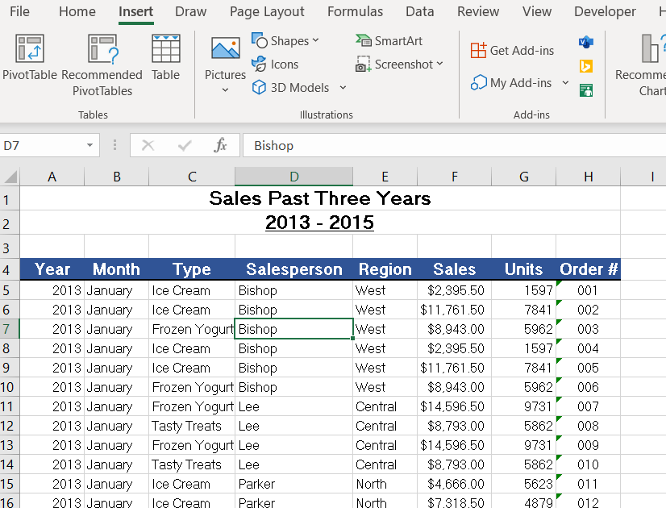

STEP 2: Select “Insert” from the Main Menu Bar and click on it.

STEP 3: Click on “ Pivot Table” Icon

STEP 4: When you click on “Pivot Table” icon, we will get a dialog box. Check the Range in this and select New worksheet for your Pivot Table.

Check the Table Range

Select New Worksheet

Click “OK”

Fields in the data set are displayed here

STEP 5: When we click on the “OK” button, we will get this window.

STEP 6: Drag the fields and drop them in the right columns, rows and values

ues.

STEP 6: Drag the fields and drop them in the right columns, rows and values.

**STEP : 7 . PIVOT Table is created**

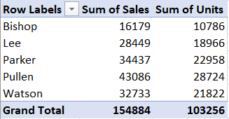

Select a “Bar Chart”

STEP 8: Create “PIVOT CHART”

Lastly, select bar chart

First, select a cell from the Pivot Table

Secondly, select “Insert” from The Menu Bar

Add Chart Elements

STEP 9: A Bar Chart is created with the fields used in the Pivot Table.

Add Chart Elements

Repeat this process twice, once for “Year” field and next for “Month” field.

Secondly Select Insert Slicer

Firstly, click on “PivotTable Analyse”

STEP 10: Now, insert slicers for month and year

Secondly, click on “Insert Slicer”

STEP 12: The following bar chart shows bars of “Sum of sales” and “Sum of Units” of each “Sales Person” sold in a particular year and month.

Just by selecting particular month and year from the “Slicers”, you can compare how much each “sales person” has sold in that particular month and year.

Q : 2. Create a Pivot Table and Group data based on “Sales Person”



STEP : 1. Select Any cell from the data set

STEP 2: Select “Insert” from the Main Menu Bar and click on it.

STEP 3: Click on “ Pivot Table” Icon

STEP 4: When you click on “Pivot Table” icon, we will get a dialog box.

Click “OK”

Check the Table Range

Select New Worksheet

STEP 5: When we click on the “OK” button, we will get this window.

Fields in the data set are displayed here

STEP 6: Drag the fields and drop them in the right columns, rows and values

ues.

STEP 6:

* Drag “Sales Person” attribute and drop it in “Row” area
* Drag “ Sales” attribute and drop it in “Values” area
* Drag “ Month” attribute and drop it in “Columns” area

**STEP : 7 . PIVOT Table is created**

STEP 8: Now, we need to group the “Sales Person”

Step 8. c) Click on “Group Selection”

STEP 8. b) Click on “PivotTable Analyse” tab on Menu Bar.

STEP 8. a) Select first two rows of “Sales Person”

STEP 8. d) Select the last Three Rows and click ‘Group Selection’

Two Group of “Sales Person” are formed.

We Can Rename and Collapse or Expand the Groups by clicking on ”-” and ‘+’

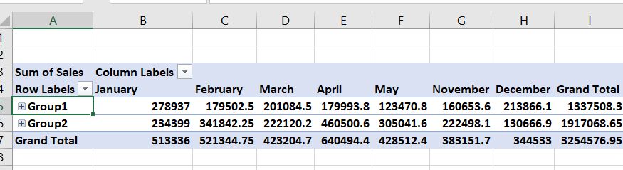

“Salesperson2” is automatically added to the Rows.

Q : 3 . Create a Shape Object and assign a macro to it that displays in message the current Date.

The following Steps needs to be followed to assign a MACRO to an Object :

STEP : 1. Click on the Insert tab in the ribbon.

STEP : 2. Click on Shapes.

STEP : 3. Select a Shape (I used an oval shape)

STEP : 4. Click and drag on the worksheet to **set** the size of the shape.

STEP : 5. You can then write some text. ...

STEP : 6. Then, right-click on the Shape and select **Assign Macro**.

STEP : 7. Pick the **macro** that we wrote.

STEP : 8. Now, Test whether your Macro is executing when you click on the Object shape Rectangle.

STEP : 1. Click on the Insert tab in the ribbon.

STEP : 2. Click on Shapes.

STEP : 3. Select a Shape (I used An oval shape)

STEP : 4. Click and drag the oval shape on the worksheet ans **set** the size of the shape.

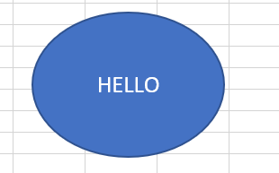

STEP : 5. You can then write some text. ...

STEP : 6. Then, right-click on the Shape and select **Assign Macro**.

Go to Visual Basic and click Developer 🡺Insert🡺module,

by right clicking on the workbook (project) and write the code

STEP : 7. Pick the **macro** that we wrote and Press “OK”.

(create a macro).

Macro that we Wrote in VBA Module

Here we are calling the ‘Date’ Function from a Sub Procedure.

‘Date’ is an in-built Excel function, which we are assigning to a variable ‘D’

The Output is :

Q : 4 . Create a Procedure that declares variables of type string and integer.

VBA is a Tool that helps users to develop programs that control Excel

It is an Object oriented programming language, OBJECTS have Properties, Methods and Events.We use Functions and Procedures in VBA .

A variable is a named element that stores information. You can assign values to variables.

Variable

Example: Interest =worksheets(“Sheet1”).Range(“A1”).Value

Few rules regarding variable names , The name must contain only letters, numbers, and underscores (no other symbols), but the first character must be a letter.

‘String’ Datatype accepts only Character’s, takes 1 byte per character, Integer accepts only numerical Data , it takes 2 bytes of memory and has a Range of -32,768 to 32,768

Letting VBA handle your data typing results in slower execution and inefficient memory use.

STEP 1: Create a New Work Book in “EXCEL”

STEP 2: Click on “Developer” Tab on the Ribbon

STEP 3: Click on “Visual Basic” icon or Press “Alt + F11 “ to activate Visual Basic Editor

Variable MyStuId is Declared as Datatype “ Integer”

STEP 4: Visual Basic Editor with 3 windows open

Code Window

Properties Window

Project Window

Run Button

Work Book created in Excel

Variable “Myname is declared as “ String” Datatype

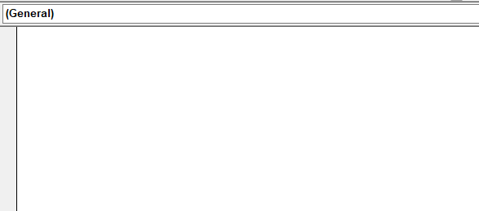

STEP 6: Now we can type the code in the “Code Window”

STEP 5: Create a Module

by right click in the module section of your project in the project window and select Insert > Module.

DIM is used to declare the variables Myname, MyFullname and MyStuID

‘&’ is used to concatenate the string and the variable value in the Message Box

MsgBox is an object used to display the output

Assigning the values to the Variables

“Sub” is a reserve word for Sub procedure

“Option Explicit” forces you to declare variables

STEP 6: Now we can type the code in the “Code Window”

Click on “Run “ Icon

STEP 7 : Select the Sub procedure name and press “Run”

Here my full name is not displayed completely as I declared it as a ‘fixed length string’

DIM MyFullName As String * 10

STEP 8: The Out put is

**EXCEL VBA PROGRAMMING PHASE 2 REPORT**

Q : 1. Create a VBA Procedure that changes the font color of table to Bold

STEP 1: Open Data Set

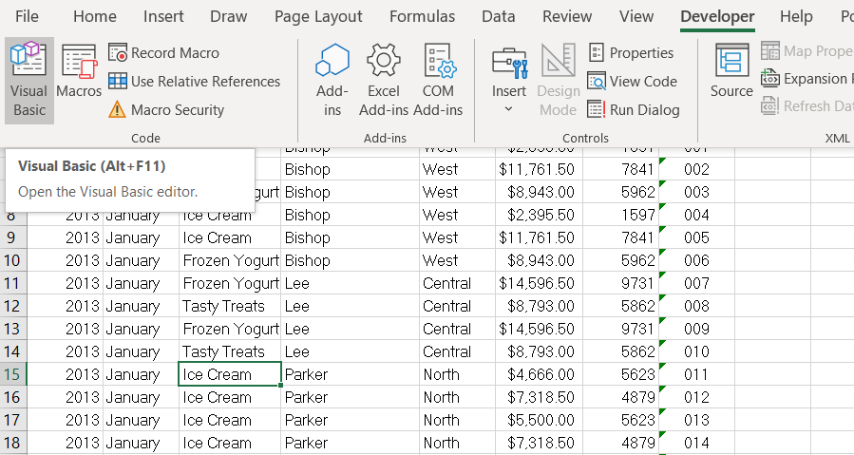

STEP 2: Select Developer Tab 🡺 Visual Basic

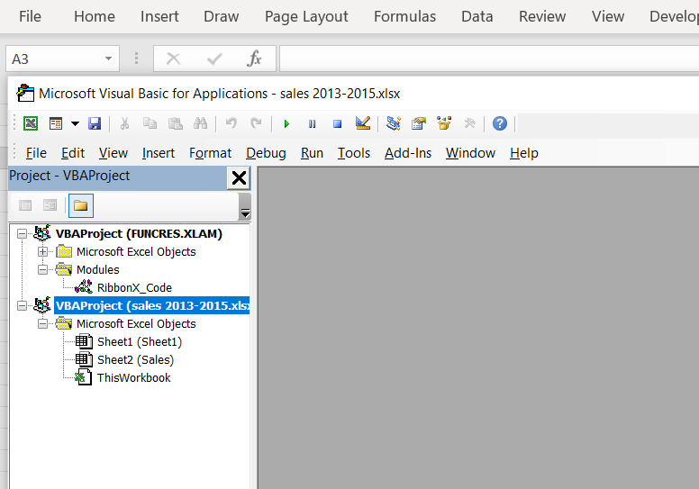

STEP 3: Select the Project

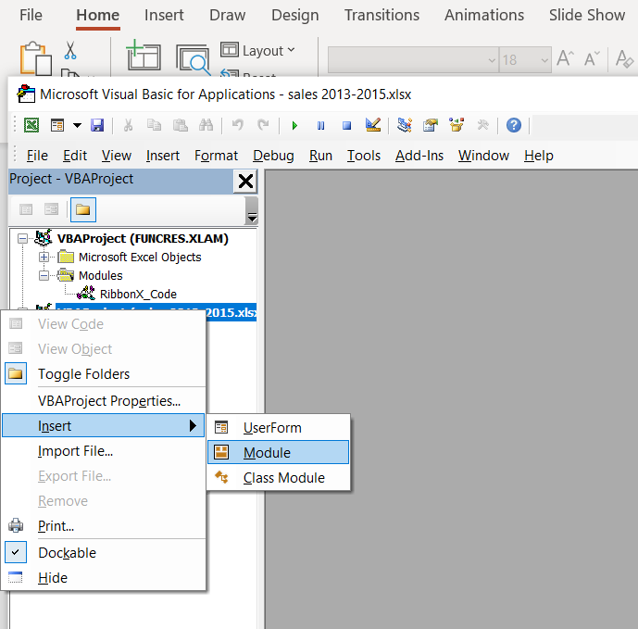

STEP 4: Insert Module

Font Property Color is assigned with Red color

Font Property Bold is set to True which returns Font Object

Initializing and assigning the “Range” object to the variable

This statement uses Bold property of the range object to return font object.

Declaring variable Rng1 as “Range” Datatype.

STEP 5 : Write the Code

STEP 6:

Before you “Run” the code, save it in “Macro-Enabled” mode with extension .xlsm

The OutPut is

Run the Code by clicking this icon

STEP 7:

The Output Font displayed in ‘Bold’ and ‘Red’ Color.

Before we Run the Code

Q : 2 . Create a VBA Procedure that adds a yellow “Explanation” Column towards right of the table

STEP 2: Select Developer Tab 🡺 Visual Basic

STEP 1: Open Data Set



STEP 3: Select the Project



STEP 4: Insert Module

Declaring Variable Rng1 as “Range” Datatype.

STEP 5:

Initializing and Assigning

Initializing and Assigning the “Range” object to the variable

Color Property of “Interior” Object is set to “vbYellow”

This statement uses “Color” Property of the “Range” Object to return “Interior” Object to yellow color

Color Property of “Interior” Object is set to “vbYellow”

STEP 6 : Run the Code by clicking this icon

Then, click Excel Icon OR

Alt + F11

STEP 7: Click on Excel Icon which takes us the Dataset in Excel

The Output is : The Right most column of the Table is displayed in Yellow color.

Q : 3 . Create a VBA Procedure that Uses a Loop

Loop is the Execution of a Block of code repeatedly.

STEP 2: Select Developer Tab 🡺 Visual Basic

If the variable is declared inside the procedure with “Static” Keyword, the value is retained with in that procedure.

If the variable is declared above the Sub Procedure with



STEP 1: Open Data Set

STEP 2: Select Developer Tab

🡺 Visual Basic



STEP 3 : Select the Project



STEP 4: Insert Module

Selecting the Range Object contained in Rng1 variable

10

End of Sub Procedure

7

Color Property of Interior Object is set for each ‘A’ cell if the Condition is satisfied

2

4

Declaring 2 variables Rng1 and ‘A’ both as Range Datatype

Conditional Statement

6

1

Sub Procedure

3

STEP 5:

8

Initializing and Assign Range Object to Rng1 variable

5

‘For’ is a Loop Statement checks for condition for each cell within the Range specified

8

Color Property of Font Object is set to ‘White’ if Condition is satisfied

‘Next’ Statement checks the condition for next cell with the Range specified

9

The Output is, The interior color of Range (“A15:D20”) is displayed in ‘Blue’ with ‘white’ Text.

STEP 6:

Q : 4 . Create a message box that displays number of executions of one procedure.

VBA is a Tool that helps users to develop programs that control Excel

The scope of the variables differs depending on the location of the declaration and the key word we use.

* Procedure Level Variable—using key word ‘Static’ or ‘Dim’ – declaring below Sub() statement
* Modular level Variable – using keyword ‘private’ or ‘Dim’ – declaring below Option Explicit before function or ‘Sub()’ Statement
* Global Variable---using key word ‘ Public’-- declaring below Option Explicit before function or ‘Sub()’ Statement

STEP 1: Create a New Work Book in “EXCEL”

STEP 2: Click on “Developer” Tab on the Ribbon

STEP 3: Click on “Visual Basic” icon or Press “Alt + F11 “ to activate Visual Basic Editor



STEP 4: Insert Module

5

4

‘&’ is used to concatenate the string and the value of Counter after every execution ,Assigning both to a string variable Msg

Initializing, Assigning and incrementing the value of “counter” variable for every execution.

7

End of Sub Procedure

6

MsgBox Object is used to Display the value of counter after every execution along with the string

3

Declaring Msg variable as String

2

Here “STATIC” is used to declare “Counter” variable which RETAINS the value of “counter” within the Sub Procedure after every execution

Sub Procedure NoOfExecu

1

STEP 5:

The Output is

Press “OK” and

Run the Code Again.

The Number of Execution keeps increasing….as you continue to run the code.

STEP 6:

Q : 5 . Create a User Form that has two Text boxes and a button to calculate sum and show it in a message box.

User Form is the interface between the User and VBA. It allows the user to communicate. User Form is a Graphical user Interface.

Click Visual Basic Tab

2

1

Click Developer

3

Insert User Form

Insert 🡺 User Form

Tool Box with Controls

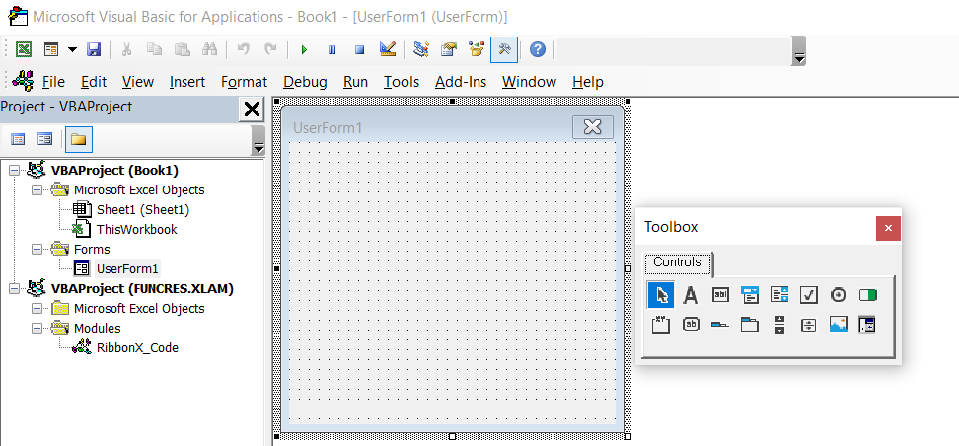

Command Button

Text Box

Label

User Form is added in the Project Explorer Window

User Form

4

Add Labels , Text Boxes and Command Button to the UserForm by Drag and Drop from the ToolBox

Change the “Caption” for each Control in Properties window by double clicking on each control in the User Form.

6

Open “Properties Window” from View

5

Properties

Window

The ‘Name’ is Very important as it is used in the code. The same name should be used for each control in its Sub Procedure.

‘Caption’ is for the Display on the user form only.

Select the User Form , Right click and view code

Double click on Command button and view code and add the following code

7. Write this code

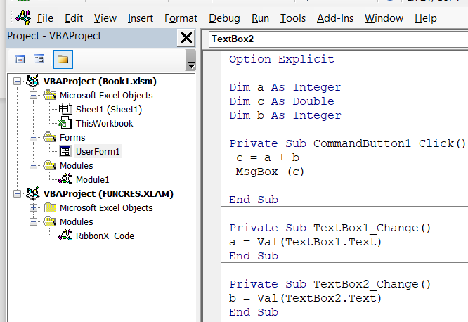

8. Insert module and write this code

Sub Procedure for TextBox2

Sub Procedure for Text Box1

Sub Procedure for Command Button

Declaring Modular Level Variables

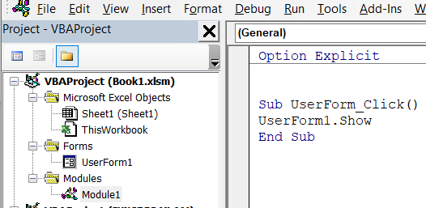

This sub procedure shows the userform when the button is clicked in the worksheet.

9. Insert Button in the work sheet and assign MACRO by right clicking on the Button

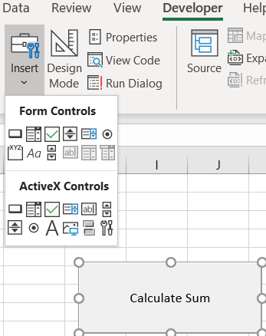

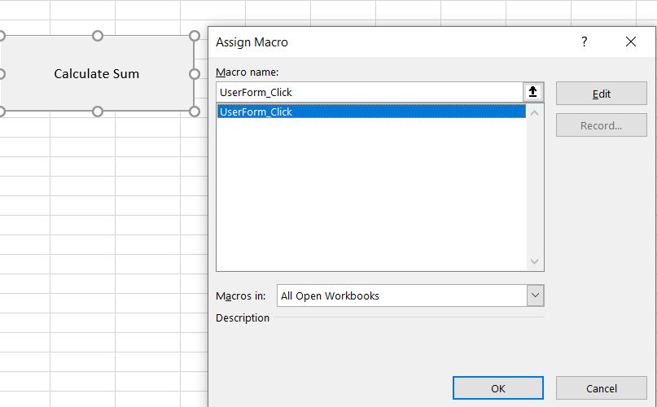

10. Go Back to Visual Basic and Run the code in the userForm

11.Now , we can Test our Userform, by going back to Excelsheet with our ‘Calculate Sum’ Button.

The Out Put is, A User Form with Text Boxes accepting 2 numbers from the user in the Text Boxes and when the user clicks Command button , Displays a ‘Message Box’ with the Sum of 2 Numbers.

Q : 6 . Create a User Form in Excel VBA to get name , Date of Birth, Gender , Telephone number, E-mail and Postal Code from the user and store the value provided by the user in the worksheet.

Click Visual Basic Tab

2

Click Developer

1

Insert User Form

3



Combo Box

User Form

User Form is added in the Project Explorer Window

Tool Box with Controls

Label

Text Box

Command Button

Change the Name and Caption of Each Control—Captions appear on the Form while The Names are hidden but, very important and used when we are writing the Code for each control.

4

Insert the Module by Selecting the Project 5

Write the Following Code in the Module Code Window.

6

Go to Excel Sheet by clicking

7

Click on “Developer” Tab and click on ‘Insert’ and Select Button from Form Controls 8

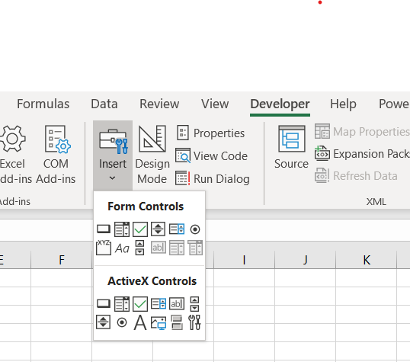

Button ( Registration ) is Created and ‘ShowDialogbox’ macro is Assigned to it

Table Headers are created 9

Go Back to VisualBasic Editor , Select the userform1 that we created and view code

10

Select UserForm from the left DropDown List

11

12

Select ‘Initialize’ from Right Drop down List

Type this following Code in the “Initialize” Userform Procedure

13

Adding Items to ‘combo Box’

This code is to Initialize and make the Text Boxes Empty before it is filled by the user

Type the Following Code

14

Double click on the “SUBMIT” Button on the UserForm and the cursor will be in the ‘SubmitButton” Procedure.

Here we are using the work sheet function on Range Object to find the Empty row and ascending by 1 column wise to enter the values provided by the users

Inputting the values entered by the user in TextBoxes in the Empty cells in the Worksheet

Code for ‘Clear’ Command Button, which Clears all the Values of the User Form

15

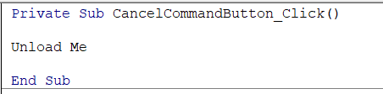

Code for ‘Cancel’ Button

The User Form Disappears when CANCEL is clicked

16

Now, Click ‘Debug’ Tab on Main Menu and Click ‘Compile’. VBA Shows any Errors in the code

Then RUN the Code

17

Now , userform can be tested by clicking on ‘REGISTRATION’ Button Created.

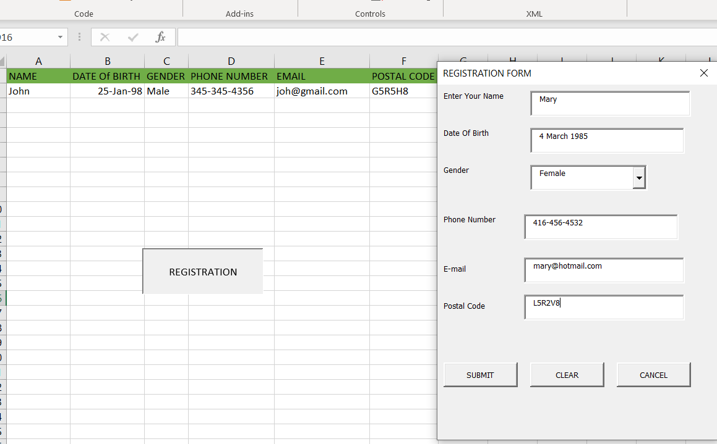

18

The Form Appears , Enter the Values and Click ‘SUBMIT’



Our Values are in the Table

